**Simple CRUD Application**

Using MEAN (MongoDb, Express, AngularJS, NodeJS)

1. Start the server inside project directory:

$: **npm start**

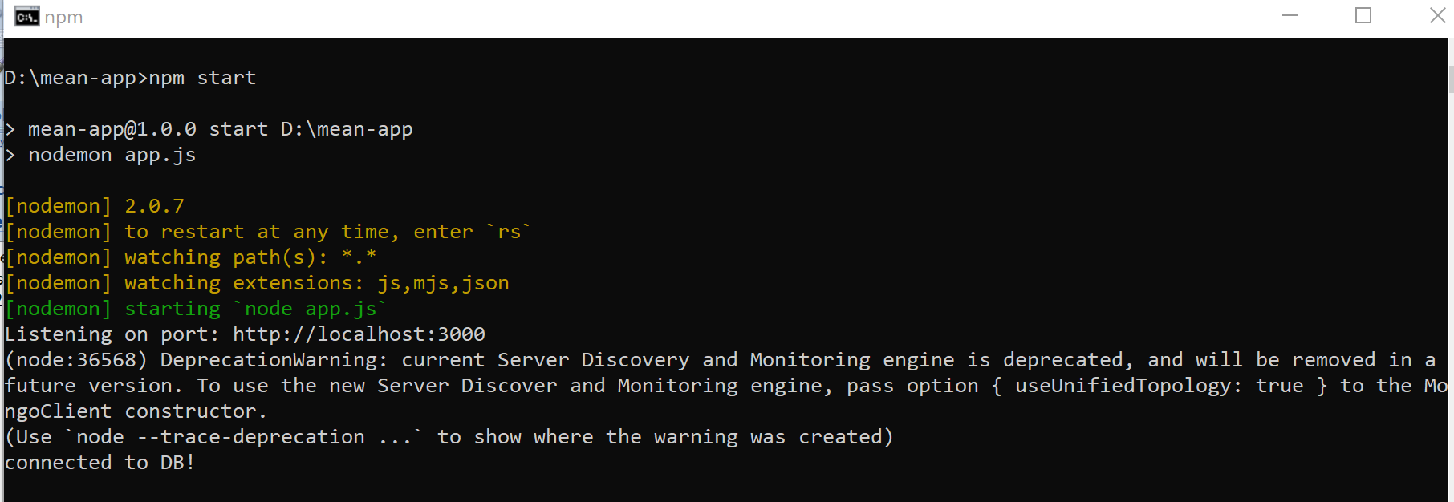

1. Open Postman.
2. Goto Home Page: <http://localhost:3000>

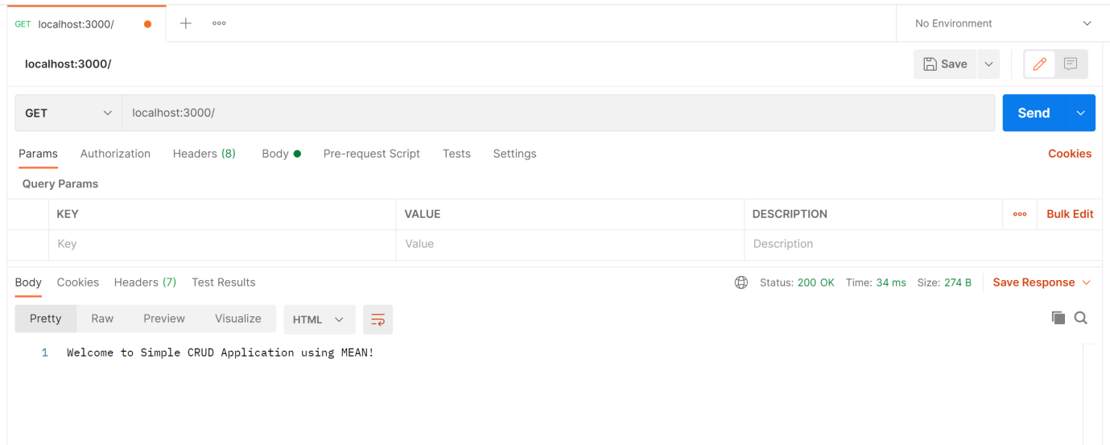

1. Get all users: (GET) <http://localhost:3000/users>

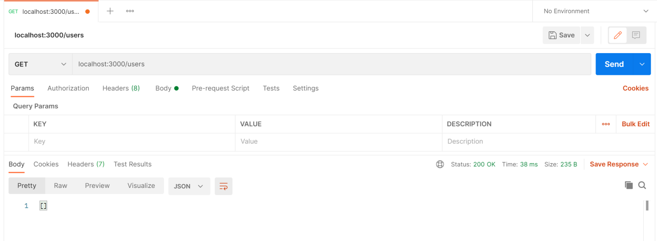

1. Add a new user: (POST) <http://localhost:3000/users>

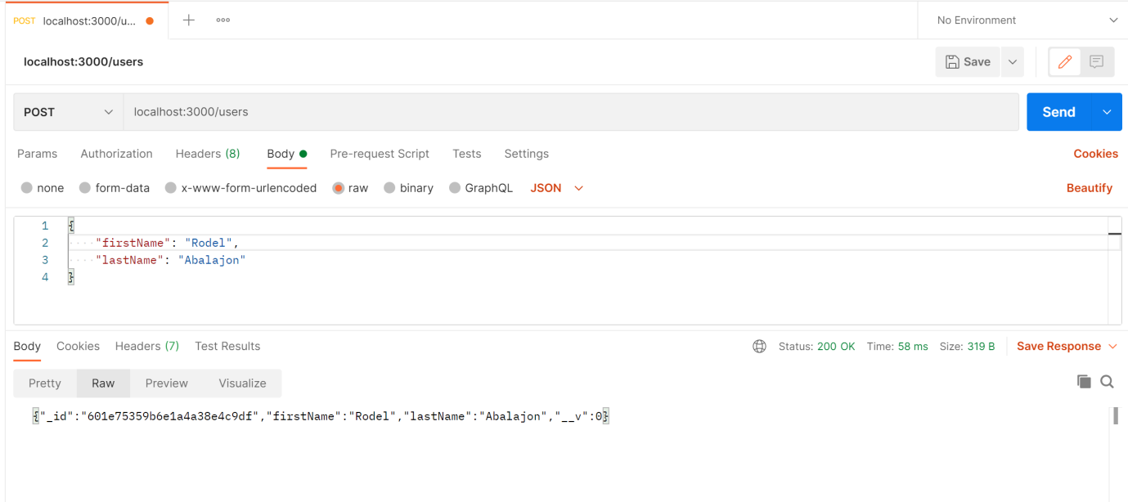

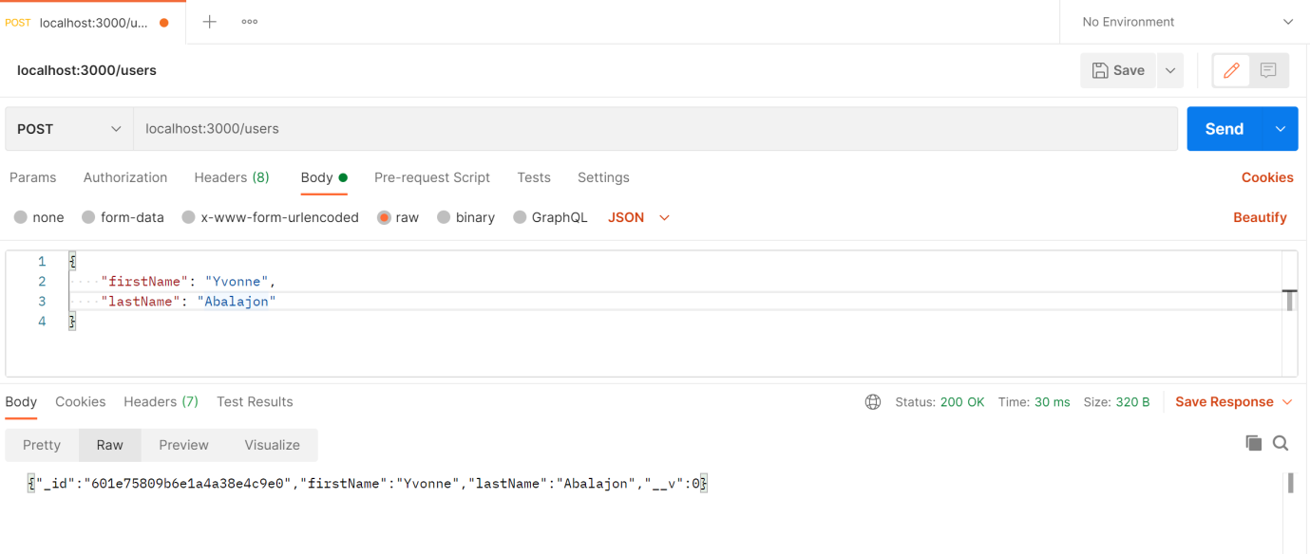

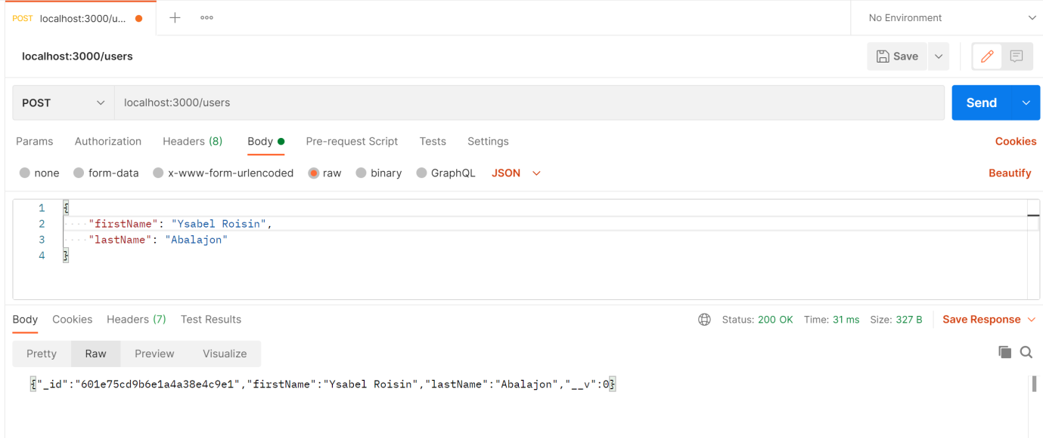

1. Check for the users being added: (GET) <http://localhost:3000/users>

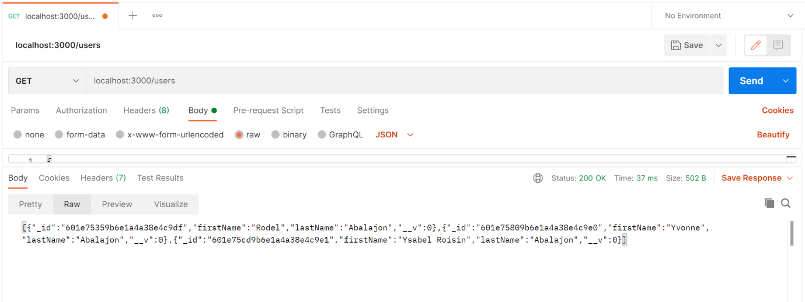

1. Check in MongoDb:

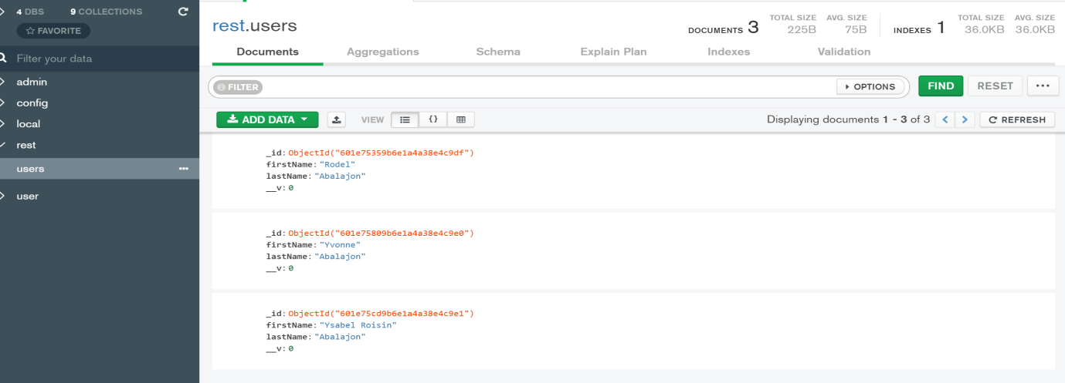

1. Update a particular User: (PATCH) [http://localhost:3000/users/${ObjectId}](http://localhost:3000/users/$%7bObjectId%7d)

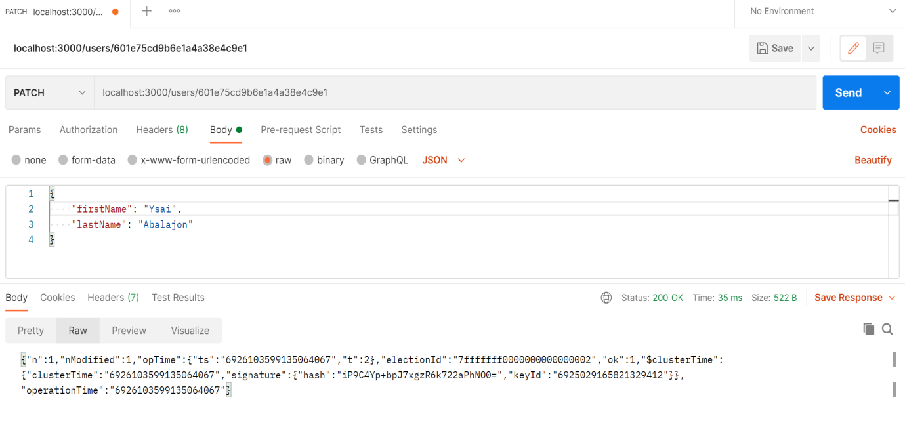

1. Checking for all users: (GET) <http://localhost:3000/users>

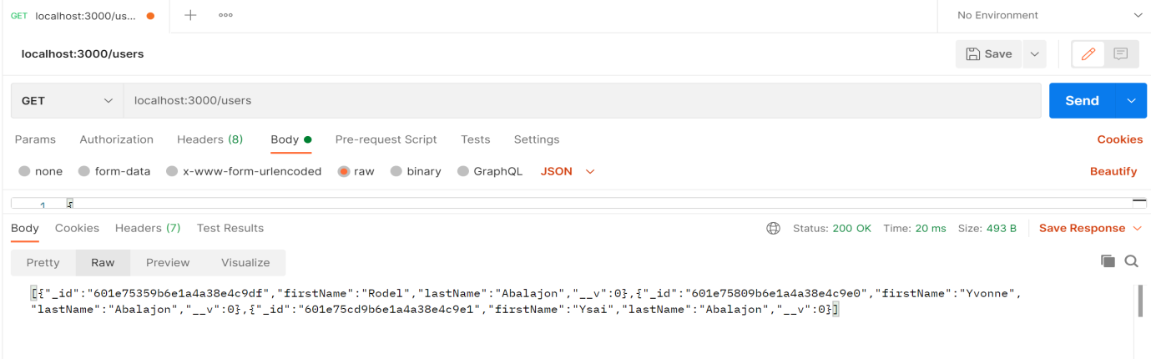

1. Check MongoDb:

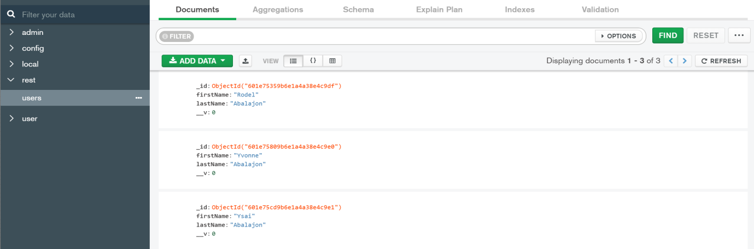

1. Delete a specific User: (DELETE) [http://localhost:3000/users/${ObjectId}](http://localhost:3000/users/$%7bObjectId%7d)

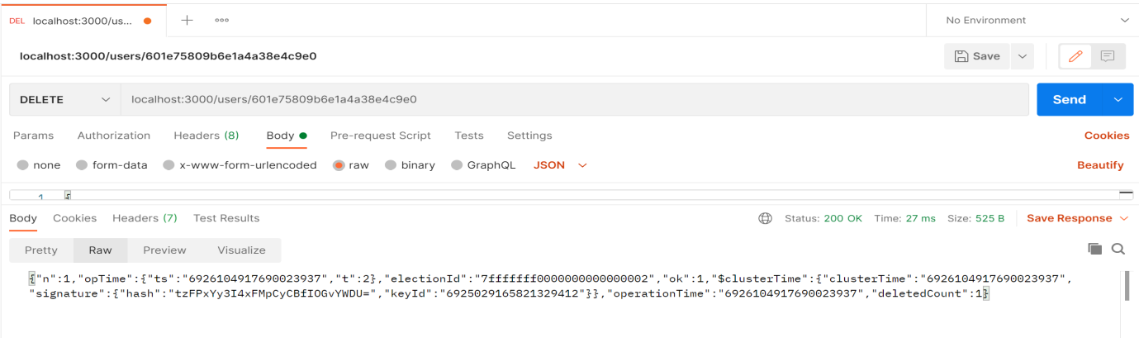

1. Checking for all users: (GET) <http://localhost:3000/users>

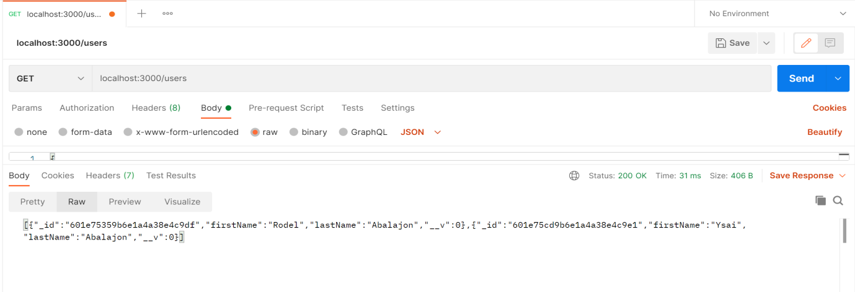

1. Checking in MongoDb:

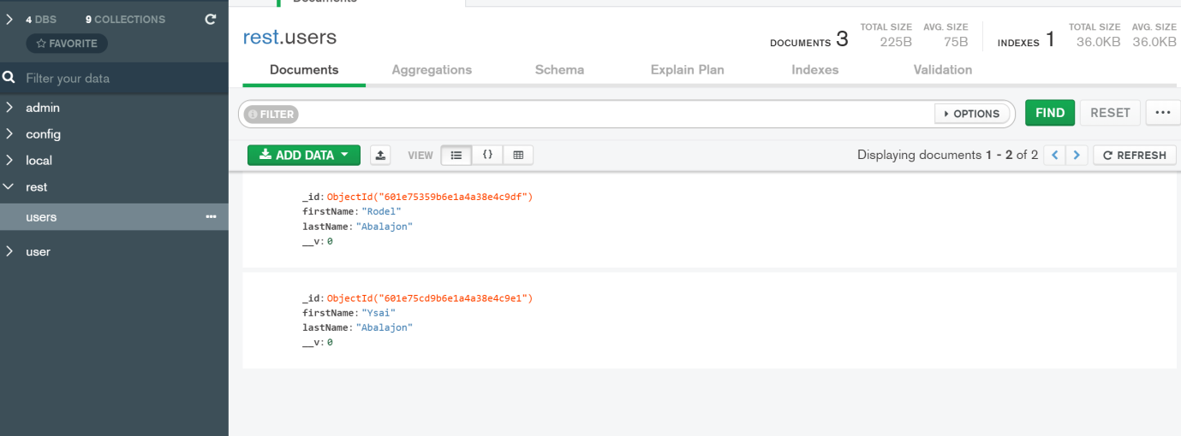

1. Checking for a specific users: (GET) [http://localhost:3000/users/${ObjectId}](http://localhost:3000/users/$%7bObjectId%7d)

